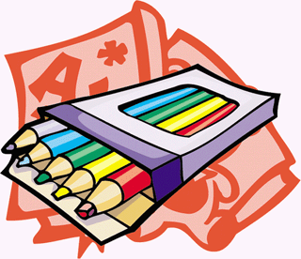
Supply List
Fourth Grade
2018/2019

**Please note: These supplies will become community classroom supplies**
- 1 folder of each color: red, green, blue, yellow
**please make sure you stick to these colors**
- 4 single subject notebooks, one of each color: red, green, blue, yellow
**please make sure you stick to these colors**
- 2 packs of pencils (12 pack)
- Flexible pencil case
(Please avoid getting the hard boxes…a pencil case that zips and is flexible is best)
- Ear buds or headphones (You can find them at the dollar store)
- 1 large eraser
- Cap erasers (for pencils)
- Hand held pencil sharpener (to fit in pencil case)
- 1 box of colored pencils OR thin Crayola markers
- 1 box of Crayola crayons
- 1 pair of scissors
- 1 pack of dry erase markers
- 1 package of post it notes
- 1 box of gallon sized Ziploc bags
- Tissue boxes
- Clorox wipes

We’re looking forward to an exciting year of team teaching in fourth grade! Have a wonderful summer and we will see you in September!

From,
Mrs. Rossi and Mrs. Lineberry

